HONORS CHEMISTRY • UNIT 4
Chemical Reactions
Write, balance, classify and predict the products of chemical reactions, then show only the particles that actually change.

HOW TO USE THIS PACKET
Write in pencil: you will balance a lot of equations. Use the blank space for particle sketches. LAB CORNER boxes are things you would see at a lab bench. Extra practice and a review are at the back.

What we will learn
4.1 | Balancing equations & writing reactions
4.2 | Types of reactions
4.3 | Predicting products: synthesis, decomposition, combustion
4.4 | Predicting products: single replacement (activity series)
4.5 | Predicting products: double replacement (solubility rules)
4.6 | Net ionic equations
4.7 | Naming & writing formulas (review)

By the end of this unit I can…
• Balance equations using coefficients and explain why equations must be balanced.
• Translate between word equations and balanced symbol equations with state symbols.
• Classify a reaction as synthesis, decomposition, single replacement, double replacement or combustion.
• Predict the products of synthesis, decomposition and combustion reactions.
• Use the activity series to predict single replacement reactions and solubility rules to predict precipitates.
• Write complete, ionic and net ionic equations and identify spectator ions.
• Name and write formulas for ionic compounds, molecular compounds, acids and polyatomic ions.
4.1 | Balancing Chemical Equations & Writing Reactions Law of conservation of mass • coefficients • state symbols

BIG IDEA
Atoms are not created or destroyed in a chemical reaction, so every atom on the reactant side must appear on the product side. We balance by changing coefficients (the big numbers in front), never the subscripts.

Key vocabulary — write each definition in your own words
Term | Definition (your words) | Example / sketch
Reactant / product | Which side of the arrow?
Coefficient vs subscript | Which one can you change when balancing?
Law of conservation of mass | What does it say about atoms?
State symbols | What do (s), (l), (g) and (aq) mean?

1. Why does a chemical equation need to be balanced? What does a balanced equation represent? (Think about a cooking recipe.)

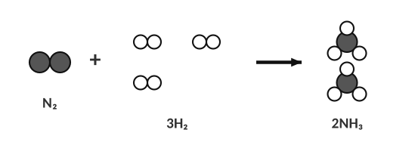
N₂ + 3H₂ → 2NH₃: 2 N and 6 H on each side.
HOW TO BALANCE (TRY THIS ORDER)
1. Write the correct formulas (diatomic elements: H₂, N₂, O₂, F₂, Cl₂, Br₂, I₂).
2. Make an atom tally for each side. Treat a polyatomic ion (PO₄, NO₃, SO₄ …) as one unit if it stays together.
3. Balance metals first, then non-metals, then H, then O last. Elements that appear in one compound on each side are easiest.
4. If you get a fraction, multiply everything by 2. Re-check every atom. Coefficients must be the lowest whole numbers.

WORKED EXAMPLE — A COMBUSTION
Balance: ___ C₂H₆ + ___ O₂ → ___ CO₂ + ___ H₂O

Work it out here:

Practice: balance each equation
Use the space under each equation for your atom tally (count each element on both sides) and your trial coefficients.
 | Balance each equation. Show your atom tally and work below it, then write the final balanced equation.
a. | ___ Na + ___ O₂ → ___ Na₂O
b. | ___ K + ___ B₂O₃ → ___ K₂O + ___ B
c. | ___ H₃PO₄ + ___ KOH → ___ K₃PO₄ + ___ H₂O
d. | ___ Al + ___ S₈ → ___ Al₂S₃
e. | ___ N₂ + ___ O₂ → ___ N₂O₅
f. | ___ H₃PO₄ + ___ Mg(OH)₂ → ___ Mg₃(PO₄)₂ + ___ H₂O
g. | ___ NH₃ + ___ O₂ → ___ N₂ + ___ H₂O
h. | ___ FeS₂ + ___ O₂ → ___ Fe₂O₃ + ___ SO₂

2. Draw particle diagrams to balance H₂ + O₂ → H₂O. Draw the correct number of molecules on each side.
Particle sketch:

Writing equations from words
HELPFUL REMINDERS
• Diatomic elements are always written as molecules: H₂, N₂, O₂, F₂, Cl₂, Br₂, I₂.
• Use the ion charges to write correct formulas (criss-cross) and then balance.
• Add states: (s), (l), (g), (aq).

Polyatomic ion | Name | Polyatomic ion | Name
NH₄⁺ |  | SO₄²⁻
NO₃⁻ |  | CO₃²⁻
OH⁻ |  | PO₄³⁻
C₂H₃O₂⁻ |  | ClO₃⁻
MnO₄⁻ |  | CN⁻

Reaction described in words | Balanced equation with states
Sodium metal reacts with chlorine gas to produce sodium chloride.
Aluminum metal reacts with aqueous copper(II) nitrate to produce aqueous aluminum nitrate and copper metal.
Aqueous nitric acid reacts with aqueous magnesium hydroxide to produce aqueous magnesium nitrate and liquid water.
Propane gas (C₃H₈) reacts with oxygen gas to produce gaseous carbon dioxide and gaseous water.
Solid aluminum oxide decomposes into solid aluminum and oxygen gas.
Solid ammonium chloride decomposes into gaseous nitrogen trihydride and gaseous hydrochloric acid.
Aqueous lead(II) nitrate and aqueous potassium iodide react to produce solid lead(II) iodide and aqueous potassium nitrate.

Turn each equation into a word equation:
Equation | Word equation
Na₂O(s) + H₂O(l) → 2NaOH(aq)
CS₂(l) + 3O₂(g) → CO₂(g) + 2SO₂(g)
K(s) + CuNO₃(aq) → KNO₃(aq) + Cu(s)
2Li(s) + 2H₂O(l) → 2LiOH(aq) + H₂(g)

4.2 | Types of Reactions Six patterns

Type | General pattern | Clue | Example
Synthesis
Decomposition
Single replacement
Double replacement
Neutralization
Combustion

Acids and bases: how do I tell them apart?
Key terms — write each definition in your own words
Term | Definition (your words) | Example / sketch
Acid | What does it release in water? What does its formula start with?
Base | What does it release in water? What does its formula usually end with?
Salt | What is left after the acid and base react?

NEUTRALIZATION
An acid and a base swap partners: the H⁺ from the acid joins the OH⁻ from the base to make water, and the leftover ions form a salt. acid + base → salt + water

Predict the salt and water
Reactants | Balanced equation | Name of the salt
HCl + NaOH
H₂SO₄ + KOH
HNO₃ + Ca(OH)₂
HBr + Al(OH)₃

Classify each reaction
# | Reaction | Type
1 | C₅H₁₂ + 8O₂ → 5CO₂ + 6H₂O
2 | 2K₃PO₄ + 3BaCl₂ → Ba₃(PO₄)₂ + 6KCl
3 | 2Al(OH)₃ + 3H₂SO₄ → Al₂(SO₄)₃ + 6H₂O
4 | 2AgNO₃ + Na₂CO₃ → Ag₂CO₃ + 2NaNO₃
5 | 2Al₂O₃ → 4Al + 3O₂
6 | 2Al + 6HCl → 3H₂ + 2AlCl₃
7 | C₄H₁₀O + 6O₂ → 4CO₂ + 5H₂O
8 | 3HBr + Al(OH)₃ → 3H₂O + AlBr₃
9 | 2NH₃ + H₂SO₄ → (NH₄)₂SO₄
10 | 2HgO → 2Hg + O₂
11 | Na₂O + H₂O → 2NaOH
12 | Cu + 2AgNO₃ → 2Ag + Cu(NO₃)₂

1. Which reaction type has the pattern AB → A + B?
A) synthesis B) decomposition C) single replacement D) combustion
2. HNO₃ + KOH → KNO₃ + H₂O is…
A) synthesis B) decomposition C) neutralization D) combustion
4.3 | Predicting Products: Synthesis, Decomposition & Combustion Reactants → products

PREDICTION RULES
Synthesis (two elements combine): a metal + non-metal makes an ionic compound. Use the group number to find each charge (Group 1 → 1+, Group 2 → 2+, Group 3 → 3+; Group 15 → 3−, Group 16 → 2−, Group 17 → 1−), then criss-cross the charges to write the formula (Mg²⁺ + O²⁻ → MgO). (If a problem combines two non-metals, the product’s formula will be given.)
Decomposition: a binary compound (two elements) breaks apart into its two pure elements (by electrolysis or strong heat). Remember the diatomic elements: H₂, N₂, O₂, F₂, Cl₂, Br₂, I₂.
Combustion: hydrocarbon (or an alcohol) + O₂ → CO₂ + H₂O (complete combustion).

Complete and balance
 | Reactants → | Balanced equation (products and coefficients) | Type
1 | Na + Cl₂ →
2 | Mg + O₂ →
3 | Al + S₈ →
4 | Li + N₂ →
5 | NaCl →
6 | H₂O →
7 | Al₂O₃ →
8 | CH₄ + O₂ →
9 | C₂H₆ + O₂ →
10 | C₂H₄ + O₂ →

1. Propane (C₃H₈) burns completely in oxygen. Which products form?
A) CO and H₂ B) CO₂ and H₂O C) C and H₂O D) C₃H₈ and O₂

LAB CORNER • Electrolysis of water

A power supply is connected to two electrodes in water. Gas collects in two inverted tubes in a volume ratio of 2 : 1.
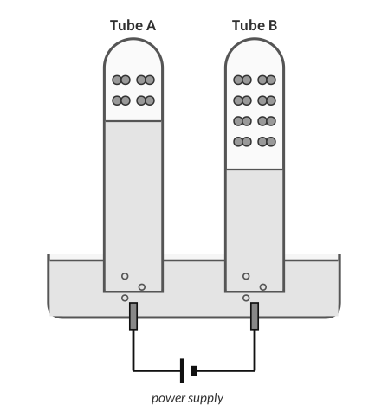
Each pair of dots is one gas molecule. Both tubes were filled by the same power supply for the same time.
2. Look at the amounts of gas collected. (a) Which tube holds hydrogen and which holds oxygen? Explain how you decided. (b) Write the balanced decomposition equation for water.
Answer:

4.4 | Single Replacement & the Activity Series A more active element replaces a less active one

BIG IDEA
In a single replacement reaction a free element swaps places with an element in a compound. It only works if the free element is more active (more eager to lose or gain electrons) than the one it replaces.

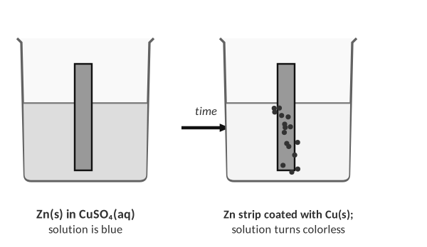
Zinc is more active than copper: Zn + CuSO₄ → ZnSO₄ + Cu.
Activity series | Most active → least active
Metals | Li, K, Ba, Sr, Ca, Na, Mg, Al, Zn, Fe, Ni, Pb, (H), Cu, Ag, Au
Halogens | F₂ > Cl₂ > Br₂ > I₂
Reacts with cold water? | Li, K, Ba, Sr, Ca, Na → metal hydroxide + H₂ (2Na + 2H₂O → 2NaOH + H₂); metals below Ca, Na do not.

1. Explain in words how to decide whether a single replacement reaction will happen.

2. Write the balanced equation for Zn + CuSO₄ and tell which metal is more active and how you know.

Predict the products (write NR if no reaction)
 | Reactants | Products (balanced) or NR
1 | Li + BaCl₂ →
2 | Li + CaS →
3 | K + BaCl₂ →
4 | Ba + NaF →
5 | Na + MgCl₂ →
6 | F₂ + NaCl →
7 | Cl₂ + NaF →
8 | Cu + FeSO₄ →
9 | Na + H₂O →
10 | Ag + H₂O →

3. Which will NOT react?
A) Zn + CuSO₄ B) Mg + FeCl₂ C) Cu + ZnCl₂ D) Cl₂ + KBr

4.5 | Double Replacement & Solubility Rules Swap partners • precipitate, water or gas

BIG IDEA
In a double replacement reaction two compounds exchange partners: AB + CD → AD + CB. In water the reaction only “happens” if one new compound is a solid (precipitate), water or a gas; otherwise the ions just stay mixed (no reaction).

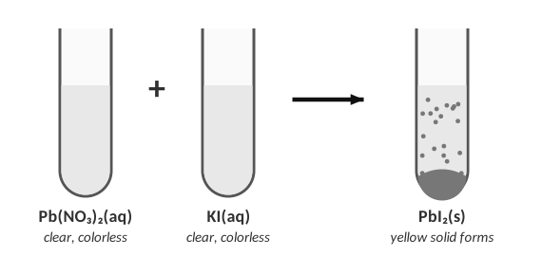
Two clear solutions form a solid precipitate (colored yellow in real life).
Solubility rules (water) | Soluble (aq) … | … except
Group 1 ions (Li⁺, Na⁺, K⁺) and NH₄⁺
Nitrates (NO₃⁻), acetates (C₂H₃O₂⁻), chlorates
Chlorides, bromides, iodides
Sulfates
Hydroxides, carbonates, phosphates, sulfides, sulfites

STEPS
1. Swap the cations. 2. Write each new formula using ion charges (criss-cross). 3. Balance. 4. Use the solubility rules to label (s) or (aq). 5. If both products are aqueous: no reaction.

# | Reactants | Products (balanced, with states) or NR
11 | BaCl₂ + H₃PO₄ (aq) →
12 | K₂SO₄ + MgF₂ (aq) →
13 | AlCl₃ + BaSO₄ (aq) →
14 | Li₂S + AgNO₃ (aq) →
15 | BaCl₂ + Na₂CO₃ (aq) →
16 | Al₂(SO₄)₃ + Na₃PO₄ (aq) →
17 | Na₂SO₄ + NH₄I (aq) →
18 | Li₃PO₄ + BaCl₂ (aq) →
19 | AlBr₃ + H₃PO₄ (aq) →
20 | Zn(NO₃)₂ + Ba(OH)₂ (aq) →

1. Which pair gives a precipitate?
A) NaCl + KNO₃ B) Pb(NO₃)₂ + KI C) NH₄Cl + NaNO₃ D) K₂SO₄ + NaCl
2. What is the precipitate when AgNO₃(aq) and NaCl(aq) are mixed?
A) NaNO₃ B) AgCl C) AgNO₃ D) no precipitate

4.6 | Net Ionic Equations Show only the particles that change

Key terms
Term | Definition (your words) | Example / sketch
Net ionic equation | What does it represent?
Spectator ion | What do the species that do NOT react get called?

HOW TO WRITE ONE
1. Balanced molecular equation with states.
2. Split soluble ionic compounds (aq) into ions. Keep solids (s), liquids (l), gases (g) and weak electrolytes together.
3. Cancel the ions that appear unchanged on both sides (spectators).
4. Write what is left; check atoms AND charge.

A student dissolves sodium carbonate and magnesium nitrate in water. The diagrams show the beaker before and after the reaction.
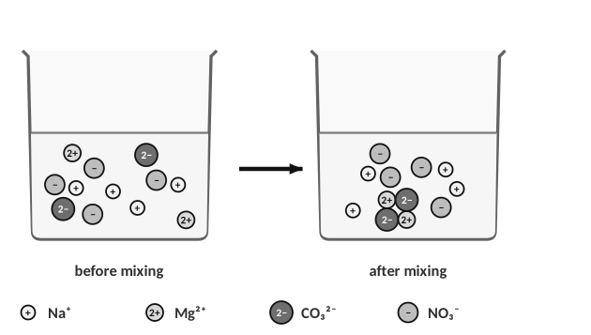
1. (a) Write the balanced equation. (b) Which ions react and which are spectators? (c) Justify with the diagram. (d) Write the net ionic equation.
Work:

Write the net ionic equation
 | Reaction | Net ionic equation
a | SrBr₂(aq) + K₂SO₄(aq) → SrSO₄(s) + 2KBr(aq)
b | 3Ca(OH)₂(aq) + 2FeCl₃(aq) → 3CaCl₂(aq) + 2Fe(OH)₃(s)
c | 2AgOH(s) + H₂CO₃(aq) → Ag₂CO₃(s) + 2H₂O(l)
d | Fe(s) + NiCl₃(aq) → FeCl₃(aq) + Ni(s)
e | Sodium sulfide(aq) + iron(II) nitrate(aq) →

2. Spectator ions are…
A) ions that form the precipitate
B) ions that stay dissolved and unchanged
C) ions that gain electrons
D) ions in the solid

4.7 | Naming & Writing Formulas (Review) Ionic • molecular • acids

Type | Rule | Example
Ionic (metal + non-metal)
With polyatomic ion
Molecular (2 non-metals)
Binary acid
Oxyacid

 | Given | Name or formula
1 | Li₂S
2 | beryllium phosphide
3 | Be(OH)₂
4 | P₂Br₄
5 | SF₆
6 | magnesium acetate
7 | diboron tetrahydride
8 | dinitrogen trioxide
9 | hydrocyanic acid
10 | lithium iodide
11 | KMnO₄
12 | HClO₃

1. Which is the correct name for N₂O₃?
A) nitrogen oxide B) dinitrogen trioxide C) nitrogen(III) oxide D) dinitrogen oxide
PRACTICE
Extra Practice — Unit 4
Show your work.

A. Balance
 | Balance each equation (show your atom tally below it)
a | Al + HCl → AlCl₃ + H₂
b | Fe + O₂ → Fe₂O₃
c | C₄H₁₀ + O₂ → CO₂ + H₂O
d | Ca(OH)₂ + H₃PO₄ → Ca₃(PO₄)₂ + H₂O

B. Classify and predict
Reactants | Balanced products | Type
Mg + O₂
HgO (heat)
C₃H₈ + O₂
Zn + HCl
AgNO₃ + CaCl₂
HCl + Ca(OH)₂

C. Precipitation lab data
A student mixes pairs of 0.1 M solutions and records whether a solid forms. Predict the result and write the net ionic equation for the ones that react.
Solutions mixed | Precipitate? | Net ionic equation
NaCl + AgNO₃
KI + Pb(NO₃)₂
NaOH + CuSO₄
KNO₃ + NaCl
BaCl₂ + K₂SO₄

D. Think
1. A student balances H₂ + O₂ → H₂O by changing it to H₂ + O₂ → H₂O₂. Explain what is wrong with this method.

2. Explain why no reaction occurs when NaCl(aq) and KNO₃(aq) are mixed.

3. Which is a correct net ionic equation for AgNO₃ + NaCl?
A) AgNO₃ → Ag⁺ + NO₃⁻ B) Ag⁺ + Cl⁻ → AgCl(s) C) Na⁺ + NO₃⁻ → NaNO₃ D) Ag + Cl → AgCl
4. Which reaction type is: 2Mg + O₂ → 2MgO?

